Photonics chips for machine learning

David Shi

**Introduction**

According a research from MIT, simulations suggest that with the help of photonic chips, optical neural networks could be run 10 million times more efficiently than its electrical counterparts (Matheson 2019).

When the data being transferred in the fiber optic cable is getting processed in a computer, the light is converted to electrons. And those electrons run through the transistors which do this conversion. The conversion takes a lot of energy and it is comparatively slow. That’s where the photonic chips come into the play. They take less energy and are a lot faster than the traditional electronic chips.

One of the reasons why photonics chips are important is that they can be one of the solutions to the end of Moore’s law. Since the electronic chips are approaching the physical limitations, it is important to find a replacement to advance the current technology.

Photonics chips can be used in various advanced technologies such as Machine Learning and Artificial Intelligence. Since Machine learning techniques are very efficient for assorted classification tasks, it is significant to have technologies like photonics chips to process the time-dependent high-speed signals that are implemented in the techniques. The importance of well designed and marketable photonics chips can be considered as the next step in the human technology process.

**Lightmatter**

Lightmatter is a startup that invent and produce photonics chips based in Boston. They plan to release a new product called Envise which is a general purpose machine learning accelerator (Computer system). Unlike the traditional processors and graphic cards, this machine uses light to send signals. It claims to have 7 times higher computer density than the NVIDIA DGX-A100 AI system. Compared to conventional chips, the photonic chips that Lightmatter are building are good at computing linear equations and this underpins a lot of scientific computing, graphic processing and machine learning (LightMatter 2021).

The computer that Lightmatter is building allows people who deploy machine learning models to use the software stacks they are familiar with. People use these software stacks to build neural networks (subset of machine learning) and store them so that the computer can interface with them.

With the pros being presented, there are also some cons to consider. Photonics computing is not good at doing logic operations, it is not capable of doing if statements.

**Noxim**

Noxim is a Network-on-Chip Simulator developed at the University of Catania. This is a simulator that can potentially be further developed to simulate Photonic Networks-on-Chip which can deliver scalable bandwidth-per-watt performance that cannot be achieved using only electronic communication (Noxim 2017).

Due to time constraints, the picture below shows an example of a duplicate result that I ran from the open source resource I found online. The result shows the program ran successfully as the creator indicated and it has the potential to be further developed.

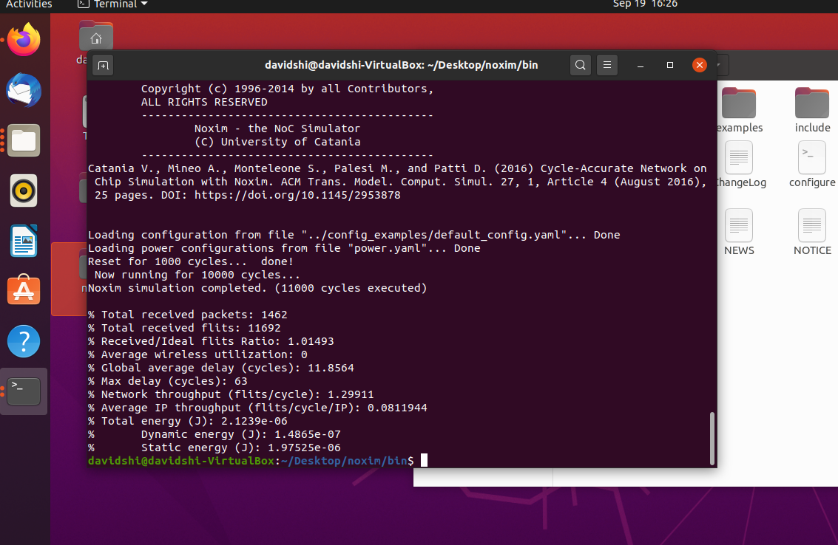

**Conclusion**

Photonics chips have the potential of being the important elements for the next generations of machine learning. And it is growing in popularity and interesting to be further discussed and developed.

Citations:

Matheson, “Chip design drastically reduces energy needed to compute with light,” *MIT News | Massachusetts Institute of Technology*. [Online]. Available: https://news.mit.edu/2019/ai-chip-light-computing-faster-0605. [Accessed: 19-Sep-2021].

“Envise,” *Lightmatter*. [Online]. Available: https://lightmatter.co/products/envise/. [Accessed: 19-Sep-2021].

Davidepatti, “Davidepatti/Noxim: Network on chip simulator,” *GitHub*. [Online]. Available: https://github.com/davidepatti/noxim. [Accessed: 19-Sep-2021].